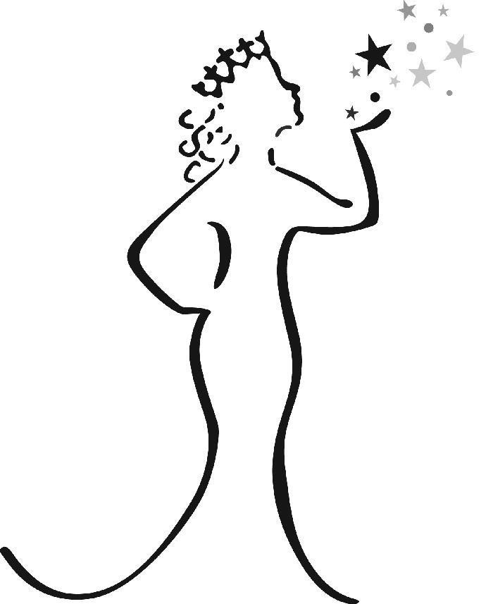
Saturday September 16, 2017
Ages 4 thru Grade 12

Contestant Requirements
- Contestants must be a resident of Ashtabula or Lake County.
- Contestant must be unmarried and remain unmarried during her reign on the Miss Grapette Court. Contestants and/or queen may not be pregnant or have a child.
- Contestant cannot have a criminal record or any pending criminal charges towards you.
- Contestants will compete in the division according to their age/grade on September 16, 2017.
- Each contestant must have a sponsor. Sponsor fee is $50.00
(nonrefundable) and is mentioned by the contestant during the pageant.
- Contestants selected for the Miss Grapette Court may not hold any other current pageant title and will not be allowed to compete for any of these titles during her reign. Royalty members may compete for Homecoming or Prom. You may only win Queen once for each age group.
- You will be required to purchase a set of name magnets at the cost of
$40.00 through Grape JAMboree that must be used during your travels. Payments must be turned in by September 19th, 2017.
- During Grape JAMboree weekend, Miss Grapette and her court become solely dedicated to the festival on Saturday September 23rd and Sunday September 24th, 2017. NO WORK, SPORTS OR HOMECOMING.
- All winners will be required to attend the royalty meeting with a chaperone on Tuesday September 19th, 2017.

Duties
- Winners will appear at public gatherings, festivals, fairs, television and radio for photographs as designated by the Geneva Grape JAMboree.
- Winners will not appear in person as Miss Grapette or a court member unless accompanied by a member of the Grape JAMboree, a designated chaperone or her parents without the Grape Jamboree’s approval.
- You will respect the judgment and abide by the rules of the chaperone(s).
- You will not hold responsible any member or members of the Grape JAMboree committee for liability in case of accident, injury, or loss, etc.
during your reign as Miss Grapette and/or court member.
- Any breach of conduct, either observed by, or reported to the committee by a reliable source, will be dismissed from the court.
- All court members must complete their requirements and mandatory events by September 23rd, 2018.
- The entire Miss Grapette court MUST plan on attending next year’s Miss Grapette pageant for farewell and to crown the new court, Grape JAMboree weekend festival and Queen’s Brunch.
- Miss Grapette court MUST attend at least 8 OFEA festivals and 9 LOCAL events during her reign, Jr. Miss and her court MUST attend 6 OFEA festivals and 7 LOCAL events during her reign. Young Miss and her court MUST attend 4 OFEA events and 5 LOCAL events during her reign. Little Miss and her court MUST attend at least 4 OFEA events and 5 LOCAL events during her reign.
- If a court member is unable to fulfill her commitments for the year she must relinquish her title to the next in line.
- Miss Grapette Queen will receive $1000.00, 1st Attendant receives $500.00, 2nd Attendant receives $250.00. Only the upper court earns a cash prize. Miss Grapette will also be paid for some of her travels and all of her luncheon meals are free. Scholarships will be paid at the end of the year.

Guidelines for Pageant
- No one but the contestant may attend the judge’s interview or enter any part of the pageant area. Little, Young & Jr. Miss contestants must have one female adult to help them during the pageant.
- All of the judges are from outside the Geneva area and the decision of the judges is final. The pageant committee does not judge the contestants in any way nor do they have access to the judges. Score sheets will not be given out after the pageant.
- Cell phone use by the contestants during the day of interviews and the pageant is STRICTLY PROHIBITED. This will result in immediately disqualification from the pageant. If a contestant needs to be contacted please use the phone number that is listed on the rehearsal sheet or speak with one of the pageant committee helpers. Parent’s/chaperone’s that are assisting their child in the back area may not use their cell phones. This includes texting. ABSOLUTELY NO PICTURES ARE TO BE TAKEN IN ANY AREA WHERE CONTESTANTS ARE CHANGING!!
- Contestants parents/guardians or other family members must understand, that there will be absolutely NO TOLERANCE from anyone making inappropriate comments or gestures to or about another contestant during the rehearsals/pageant!
- Contestants will be scored on interview, introduction on stage and formal wear. Miss Grapette contestants will perform a 2 to 3minute commercial. Skit/commercial topics will be given to contestants on September 6th’ Q & A meeting. Jr. Miss contestants will not perform a skit this year.
- Miss Grapette & Jr. Miss Grapette finalists will be judged on their on-stage question.
- All other contestants who do not make it into the finalists round MUST STAY and participate for the entire pageant. Parents/guardians WILL NOT be allowed to enter the back area after the finalists have been named.
- Black casual/dress full length pants and black shoes are required for the first half of the pageant. No Capri pants, jeans or tennis shoes. A pageant T-shirt will be provided.
- Formal Wear Attire - Ages 4 to grade 2, may wear short or long gowns. Grades 3 thru 5th , gowns cannot be above the knee. For grades 6th thru 12th a formal full length gown is required. No cut out sides or backs, you may not show your lower back or stomach, no slits above the knees, no high – low gowns, no tea length gowns. No flip flops or sandals may be worn on stage. Gowns should be age appropriate. Remember Wholesomeness, points will be deducted for attire not meeting regulations and you can be removed from the pageant!
- Interview Attire – Age 4 thru grade 5, can wear a dress, nice school outfit or be creative and have fun. Grades 6 thru 12, please wear business attire.
- Make - Up rules – Age 4 thru 2nd grade, no make - up is allowed. Grades 3 thru 5, very light (less is best). Grades 6 thru 12, make up must be natural looking. Contestants may not wear fake eye lashes. Look your age.
- Hair rules – Contestants cannot wear wigs. Small hair pieces are allowed.
- Flippers(fake teeth) are not allowed.
- Absolutely no spray tanning.
- No visible tattoos or body piercings will be allowed.

The Miss Grapette Pageant IS NOT a beauty pageant or a glitz pageant.

Rehearsals
WEDNESDAY September 6th at 7:00p.m. Q & A Meeting at Geneva High School Auditorium 1301 S. Ridge
East. NEWSPAPER PICTURES FOR ALL AGES!

TUESDAY September 12^{th _} Ages 4 thru 5th grade 5:30p.m. to 7:30p.m., 6th thru 12th grade 7:30p.m. 9:00p.m.
WEDNESDAY September 13th – Ages 4 thru 5th grade 5:30p.m. to 7:30p.m., 6th thru 12th grade 7:30p.m. to 9:00p.m.
THURSDAY September 14th – Ages 4 thru 5th grade 5:30 to 7:30p.m., 6th thru 12th grade 7:30p.m. to 9:00p.m.
DO NOT BE LATE FOR REHEARSALS!!
REHEARSALS – The same dress codes for school applies during rehearsals. You may want to wear your dress shoes during the rehearsal to help you get used to walking in them on stage.
INTERVIEWS
Preliminary judging for all of the contestants will be on Saturday morning. Business attire is recommended for your interview. Interview times will be given out on Thursday September 7th. Please arrive early for your interview. The oldest court will be voting on Miss Congeniality, someone you feel was extra friendly and helpful at this time. Winner will be announced at the pageant. Check into the auditorium for your interview. Do not leave your interview without your pageant T-shirt.
NO PARENTS, FRIENDS OR BOYFRIENDS ARE PERMITTED TO ATTEND THE REHEARSALS OR PRELIMINARY
JUDGING. PARENT’S ARE MORE THAN WELCOME TO WAIT IN THE CAFETERIA AREA DURING
REHEARSAL’S. NOONE IS PERMITTED IN THE DRESSING ROOM OR HALLWAY THE NIGHT OF THE
PAGEANT. PARENT/GUARDIAN MUST HAVE THE PROPER WRISTBAND FOR ACCESS IN THESE AREAS TO HELP THEIR DAUGHTER. If something is needed prior to the pageant, a committee member will help or escort you. During the pageant, the restricted areas are off limits, NO MEN OR BOYS ARE PERMITTED!
PAGEANT NIGHT: Reminder to parents, everyone but the contestant must purchase a ticket for admission to the pageant. Adults tickets are $6.00 each and children under 12 are $4.00. Pageant is open to the public.
TICKET SALES: Ticket sales begin at 2:00p.m. Auditorium Doors open at 2:30p.m. Little Miss & Young Miss pageant begins at 3:00p.m. Miss & Jr. Miss Pageant begins at 6:00p.m.

Cover Letter
Name:________________________________________
Age:_______ Grade:_____________________________

Attach a 5 x 7 photo here.
DO NOT WRITE IN THIS AREA.
DO NOT DECORATE THIS PAGE

Please take the time to make your application neat. The interview is the biggest part of your score. Include a head shot photo. No computer printed photos!!!!

Personal Bio
Sponsor’s Name of Business:__________________________Locale:____________

First Name:___________________Middle:_____________Last:______________

Mailing Address:________________________________City:_________________

Hometown:_________________ Zip Code:_________________________

Phone Number:___________________________ Age:____________

Birthdate:_____________________ School:_______________________

Grade:_________

E-Mail:_____________________________________________________

DO NOT USE A PENCIL TO FILL OUT YOUR APPLICATION. Make sure your application is written neatly. Sloppy applications will not be accepted.

Personal Description
List any clubs/organizations you participate in church/school.
___________________________________________________________________ ___________________________________________________________________ ___________________________________________________________________
What kind of extracurricular activities do you participate in sports, dance etc?
___________________________________________________________________ ___________________________________________________________________
___________________________________________________________________
List local community services you have participated in.
___________________________________________________________________ ___________________________________________________________________ ___________________________________________________________________ Hobbies and Interests.
___________________________________________________________________
___________________________________________________________________
Ambitions for the future and goals in life. Please use paragraph form, you may use another sheet of paper. This information will be used for the pageant.
___________________________________________________________________
__________________________________________________________________
___________________________________________________________________ ___________________________________________________________________
___________________________________________________________________
___________________________________________________________________
___________________________________________________________________
T- Shirt
Each contestant will receive a T-shirt for the Pageant.
Please circle the size you need and turn it in with your application.

Youth S M L
Adult S M L XL

Reminder
Please do not send cash. Make checks or money orders payable to
Geneva Grape Jamboree
Mail or drop off application to
Chrissy Jeppe 336 Vine St. Geneva, Ohio 44041

Signatures
( ) I understand that the $50 entry fee is non-refundable.
( ) I am aware that my check is to be made out to: Geneva Grape Jamboree
Business Name:_______________________________________________
Name:(Printed):_______________________________________________
Signature:____________________________________________________

CONTESTANT: Please check all that apply, sign and return.
( ) I have read and understand the Contestant’s Requirements page.
( ) I have read and understand the Guideline’s page.
( ) I have read and understand the Queen’s Duties.
( ) I have read and understand the Rehearsal Schedule.
( ) I have read and understand that I must complete all of the mandatory events that are required for my grade division.

Name(printed):_______________________________________________
Signature:____________________________________________________

